INTERCHURCH BIOETHICS COUNCIL, 2018-2019
REPORT TO the aNGLICAN CHURCH OF AOTEAROA NEW ZEALAND AND POLYNESIA.

The InterChurch Bioethics Council (ICBC) is an ecumenical cross-cultural body supported by the Anglican, Methodist and Presbyterian Churches of Aotearoa New Zealand. ICBC members have expertise and knowledge in science, ethics, theology, medicine, education and mātauranga Māori (Māori knowledge). Biotechnology relates to biological, medical, environmental and agricultural technologies derived from science. Bioethics is an interdisciplinary category of ethics that provides the framework for policy and decision-making with regard to scientific research and resulting technologies; including future consequences, legal, political, commercial, theological and social aspects.

Vision:
Exploring the spiritual, ethical, cultural, technological and evidential dimensions of bioethics and its consequences in Aotearoa New Zealand.

Mission Statement:
To increase the knowledge and understanding of church members and the wider community around the spiritual, ethical, cultural, technological and evidential issues relating to bioethics. To enable and encourage citizens to take action on these issues.

Our key tasks are:
- To increase our own knowledge and understanding of the interface between spirituality and biotechnology.
- To engage in consultation and dialogue with church members, community groups and specialists on the ethical, spiritual and cultural issues raised by biotechnology.
- To undertake and promote education on these issues within the community.
- To make appropriate submissions to Government and other relevant organizations on important issues of ethical and spiritual concern.
- To be an advisory body to our national church organisations by responding to requests for a positional stance on bioethical issues from our national church bodies.

For Church members the most important part of our work will be found on our website. Every congregation should include www.interchurchbioethics.org.nz as a resource. You can also find us on Facebook at www.facebook.com/InterChurchBioethicsCouncil. The website is continually updated and contains study guides, papers, and reports that can give a framework or guidelines for ethical enquiry that is separate from what appears in the mass media.

Key Tasks/Activities:
The past two years have been a busy time for the ICBC with several ethical issues being prominent in New Zealand society. On these issues, the ICBC is being asked to assist with policy statements from its member churches.

- Submissions to Government and other Organisations.

- 2018-2019 saw the Justice Select Committee and Parliamentary process continue for the End of Life Choice Bill. The ICBC presented both written and oral submissions on the Bill. Members were also active in public speaking events against this legislation, across the country. One such event was a public discussion in Christchurch Cathedral between David Seymour and Graham O’Brien (ICBC) hosted by Christchurch MP Duncan Webb. The ICBC was also involved in drafting the “Church Leaders Letter” that was signed before the third reading of the Bill (Nov 2019). It is expected that the ICBC will continue to be involved in opportunities to raise awareness about the End of Life Choice Bill as it goes to a referendum in 2020.

- The ICBC produced a written submission on the Abortion Legislation Bill to the Abortion Legislation Committee outlining our concerns with the proposed law change. Our summary statement captures our stance:
While the ICBC may consider supporting the decriminalisation of abortion practices while retaining the highest level of medical practice, controls, reporting and support services, the proposed legislation negates any rights/voice held by the fetus/child. Therefore, we would not be supporting the Abortion Legislation Bill in its current form.
The ICBC were invited to appear before the select committee, but unfortunately none of our members could appear. This was disappointing as we were aware of many other groups who were not invited to present an oral statement.

- ACART released a public consultation document of Posthumous Reproduction which the ICBC responded to.

- Engage in consultation

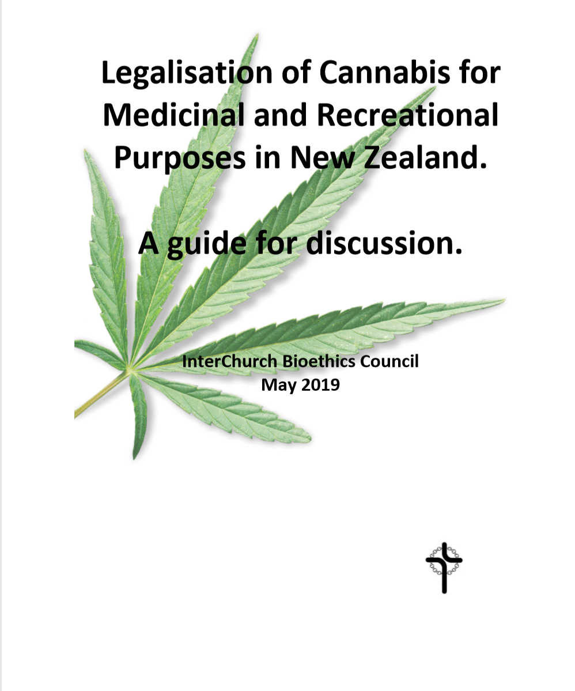
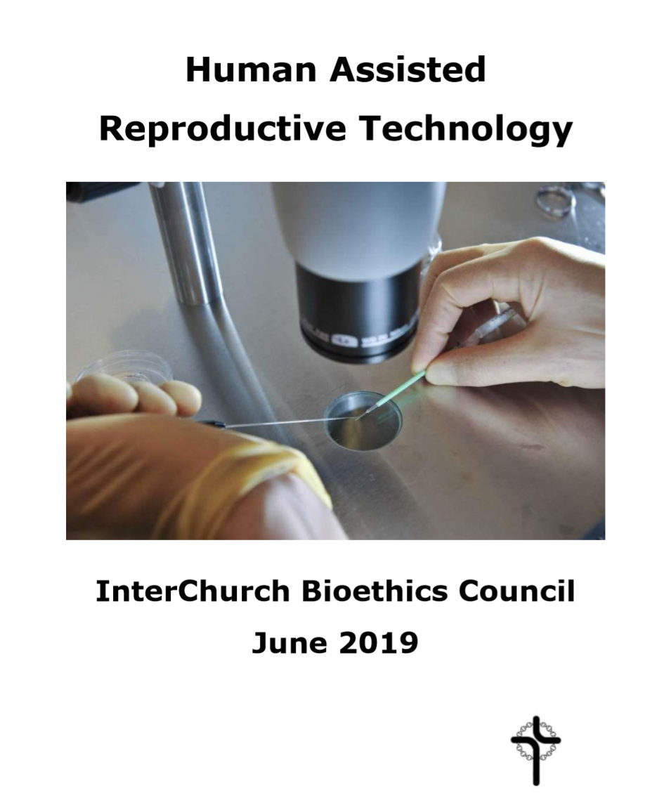
Two new resources were produced. The first was a study guide on Assisted Reproductive Technologies (ART) in which the ICBC tried to outline a series of theological and ethical principles and questions as Christians come to terms with this new technology.

The second resource was a discussion document on the use of cannabis for medicinal and recreational use, in the hope that this will be useful as Christians and the general public vote on this issue in a binding referendum in 2020.

- Undertake and promote education in the community

The ICBC has continued to support the mahi and initiatives of the Centre for Science and Citizenship (www.nzcsc.org) and it’s enQuiring minds programmes. The Centre for Science & Citizenship (CSC) was established as an independent charitable trust in 2014, to provide educational opportunities that enable school and community groups to critically engage with and explore a range of ethical issues that currently challenge us as individuals and communities.
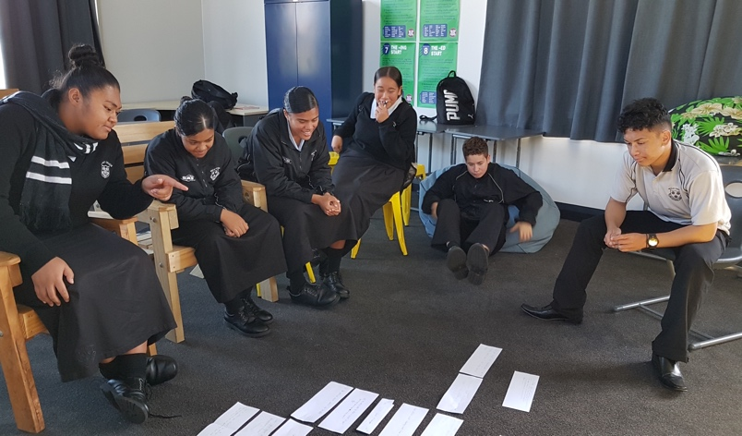
The CSC’s interactive enQuiring minds student workshops nurture the ability to investigate an issue, engage in thoughtful discussion and develop a passion for social justice. For example, the picture opposite captures a group of Year 10 students from Wesley College, Auckland, discussing the production of synthetic food. This included their critical response to producing and consuming lab grown meat.

During the 2018-2019 year, the ICBC has supported the mahi of the CSC through provision of scholarship funds. These scholarship funds have included:

- Offering coverage of registration fees for Chaplains and Religious Studies teachers from denominational schools to attend CSC facilitated Teacher Professional development workshop days. One chaplain attended.

- The CSC, in association with the Nathaniel Centre, are facilitating a teacher professional development workshop on the Ethical Issues at the End of Life in Tauranga mid-March 2020. The ICBC has reiterated their offer to denominational schools to provide a scholarship to cover registration fees. At the time of writing, three scholarship registrations have been received for this March teacher PD event.

- The ICBC also sponsored a Yr10 workshop at Wesley College (photo above), which was well received by the students.

The ICBC continues to look for ways that the CSC and its enQuiring minds programmes can connect with our denominational schools.

One of our members (Nicola) is co-director of New Zealand Christians in Science, and the interests of ICBC and NZCIS also overlap. NZCIS has a mission to support Christians who are scientists in the academy and in churches and to educate the churches on matters of science, especially in areas of technology and the environment. This year NZCIS has sponsored the Winter Lectures at the University of Auckland on the Ethics of Extinction, and a Conference at Otago University(Beyond Conflict), which included a strong eco-theological theme, with guest speakers Profs Barbara Rossing from Chicago Lutheran Seminary and Andy Gosler from Oxford University.
4. Increase our own understanding

One feature of the ICBC’s role is to be informed about advancing science and technology and the issues this raises. Members have attended talks and conferences and in doing so provide reports and lead discussion to inform the whole group. The ICBC also tries to keep its website relevant with links to a range of organisations. We have also been privileged to have expert speakers attend our meetings and discuss their topics with us. One such speaker was Simon Wright from Climate Engineering Impacts on New Zealand (CLEINZ). Events attended by members include:
- Trans-materialism and Wellbeing Conference
- Introduction to Data Ethics
- Royal Society Workshop on gene editing in Health care
- Surrogacy Symposium
- Evidence to Everyday symposium on nutrition
- NZ Bioethics Conference
- NZCIS conference
- Seminar with Leonie Herx on End of Life Care

Membership:

Over the past two years we have had some “retirements from the ICBC”. Many thanks to Noel Tiano (Presbyterian) and Paul Reynolds (Anglican) for their contribution and willingness to be consulted as required in the future. We view membership from Pakeha, Māori and Polynesia as an important aspect of the ICBC, and it has been difficult to fill vacant seats on the committee to provide diversity and expertise.

To help the ICBC be a representative body for our churches, we feel it would be useful to have 2 seats on the ICBC open to Christians from other denominations and with the required expertise. This will ensure that the ICBC can continue to speak with authority on the ethical, cultural and spiritual dimensions of bioethical issues.

Recommendations:

As the ICBC we see ourselves as a resource for our member Churches and wider Christian community. As such we welcome opportunities to engage in discussion and provide resources. Our recommendations are:

- This Report is received.

- The Anglican members of the InterChurch Bioethics Council for the next two years will be: Rev Dr Graham O’Brien (Co-chair, Nelson), Dr Deborah Stevens (Wellington), Dr Nicola Hoggard-Creegan (Auckland), Dr Tania Stuart (Auckland).

- That the membership of the ICBC can include two Christian representatives with the appropriate expertise and cultural mix from outside of the Anglican, Methodist and Presbyterian Churches, to provide the ICBC with a diversity of experience and cultural perspectives.

Finances:
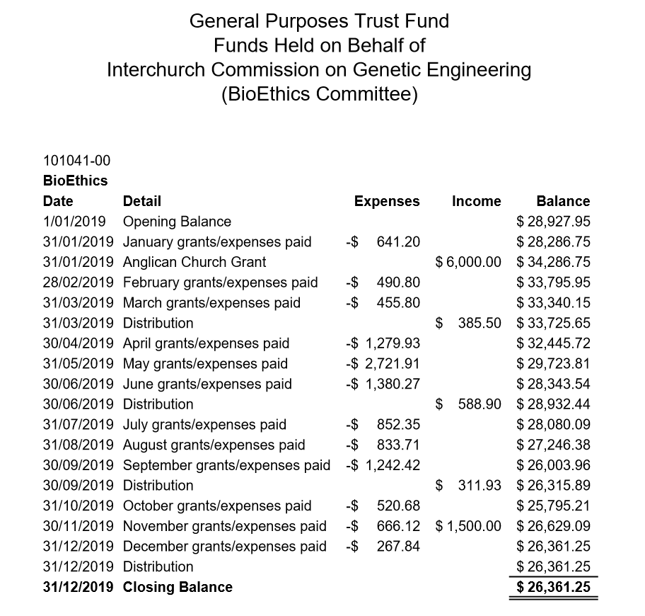

We thank the Anglican Church of Aotearoa, New Zealand and Polynesia for their continued support of the ICBC.


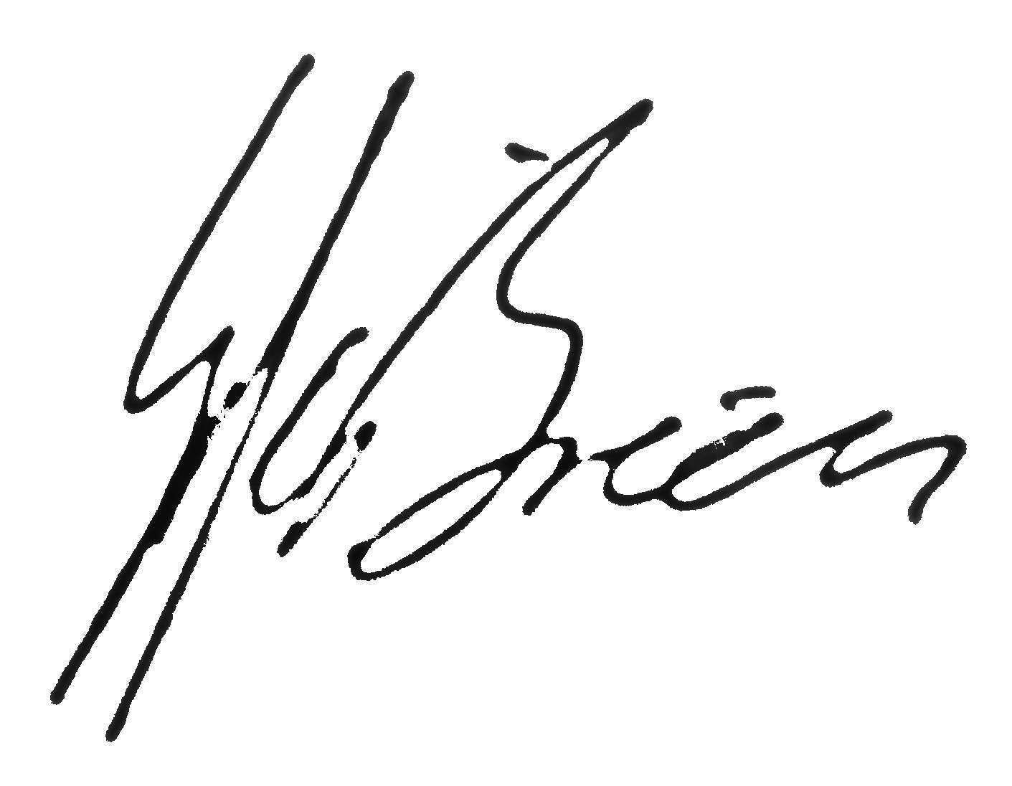

Rev Dr Barbara Peddie and Rev Dr Graham O’Brien Co-Chairs.

December 2019.

